

**Year 12 Human Biology**

**Extended Response: Nervous System**

|  |
| --- |
| Name: |
| Teacher: |

|  |  |  |  |
| --- | --- | --- | --- |
|  | Marks Received | Marks Available | Percentage |
| Total |  | 25 |  |

Assessment Time: 40 minutes

Weighting: 5%

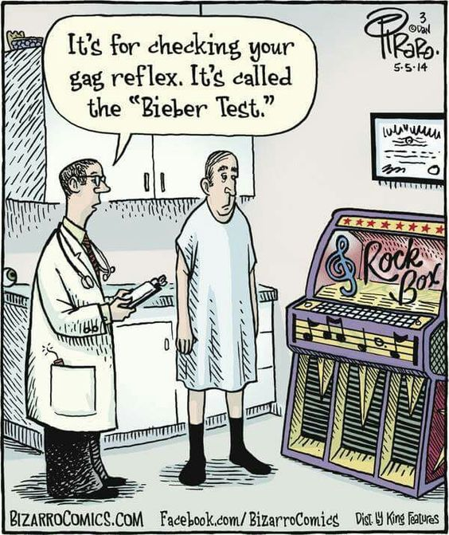

You must **answer all questions** in the booklet provided. Please clearly number questions and use the paper at the back of the booklet if you wish to plan your answer. Clearly label your plan.

**Nervous System Extended Response 2017**

Question 1) Discuss how nerve impulse are generated and propagated in a myelinated neuron. (13 marks)

**Generated**: (max 11 marks)

• Neurons are normally polarised / negatively charged inside the axon compared to extracellular fluid/ -70mV charge

• Stimulus is received triggering some sodium channels to open

• Sodium moves down the concentration gradient into the axon

• Stimulus may be neurotransmitters from a neighbouring axon

• Or a receptor may trigger some sodium channels to open

**Propagated**:

• If the threshold is reached the impulse is initiated/ voltage gated sodium channels open

• Sodium floods into the axon and causes it to become depolarised

• This triggers adjacent voltage gated sodium channels to open – causes depolarisation in adjacent membrane

• Sodium channels close and potassium channels open

• Potassium floods into the axon causing it to become repolarised

• Sodium potassium pump achieves this resting potential by pumping three sodium ions out of the axon and two potassium ions into the axon.

• Sodium potassium pump restores ion concentrations

• High concentration of sodium in extracellular fluid (low in axon)

• High concentration of potassium in axon (low in extracellular fluid)

**Myelinated Neuron:** (must have 2 mark)

• Nerve impulse jumps from one Node of Ranvier to the next

• A process called salutatory conduction

Question 2) Human skeletal muscle is activated by a complex relationship between nervous stimuli and the process inside the muscle fibre.

Draw an annotated, labelled diagram which shows the pathway taken by a nerve impulse in a spinal reflex arc and explain three (3) ways in which is it considered to be a protective mechanism.

(12 marks)

**Labels**  ½ mark each (max 3 marks)

• Sensory neuron

• Motor Neuron

• Relay Neuron

• Effector

• Receptor (at beginning of sensory neuron)

• Stimulus

**Direction** of nerve impulse shown in diagram (1 mark)

**Spinal cord labels** ½ mark each (max 2 marks)

• White and grey matter in spinal cord correctly labelled (relay neurons in inner grey matter)

• Motor and sensory neurons synapse with interneuron in the grey matter of the spinal cord

• Dorsal root ganglion correctly labelled

• Ventral root correctly labelled

**Annotations –** neuron functions 1 mark each (3 marks)

• Sensory neuron carries impulses from receptor to CNS

• Motor neuron carries impulse from CNS to effector

• Interneuron carries impulse within the CNS, connecting sensory and motor neurons

**Protective mechanism:** ½ mark each (max 3 marks)

• Reflex is quick/ doesn’t go to the brain / only 3 neurons

• Removes the body from harm quickly

• Stereotyped – same response each time

• Response matches stimulus every time to prevent harm

• Involuntary – no conscious thought

• No opportunity to delay/change response and not prevent harm